In-Class, Open Book Examination II

May 5, 2015

The work on this examination is to be your own and you are expected to adhere to the UMass-Boston honor system. All questions can be answered by one or two short sentences. Do not try to make up for a lack of understanding by providing a rambling answer.
Note: I give partial credit! Show all work!

1. (20 points) Short Questions
- (2 points) How does the CPU know who is doing the interrupting?

- (2 points) What is the purpose of the assembly language wrapper in the interrupt service routine?

- (4 points) How does CPU handle serial I/O and timer interrupts(check either yes or no)?

Disable interrupts coming from the device:

For serial I/O: yes __ no ___
For timer: yes ___ no ___

Mask interrupts using the PIC:

For serial I/O: yes __ no ___
For timer: yes ___ no ___
A
- (2 points) Synchronous flip-flops only change states when clock is ________.

- (2 points) How come sequential logic cannot
be completely described by pure truth table
on inputs?

f. (2 points) What is the difference between main memory and cache memory?

g. (2 points) For a n-bit selector, what is the minimum number of selector lines(S1, S2…) you need to select one of the 10 inputs?

__________________________

h. (4 points) If A is a clock, draw the output C.
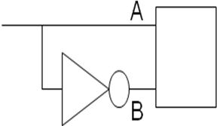
AND
C

C

2. (20 points) Evaluations
In mp3’s timing package, the following times are recorded:

Downcounts: 3500 2500 100 100 downcounts downcounts before tick before tick
+----------+ +--------------------+
--+-------------------------+------------------------+--------------------------+
tick ^ ^ tick ^ tick ^ tick
200 A starts A ends 201 B starts 202 B ends 203

For task A:

At starttimer(), tickcount=200, downcount=3500
At stoptimer(), tickcount=200, downcount=2500

For task B:

At starttimer(), tickcount=201, downcount=100
At stoptimer(), tickcount=202, downcount=100

Assuming time for 1 downcount = 1 microsecond, what is:

- the duration of task A:
______________________

- the duration of task B:
______________________

- the duration between A and B start times:

______________________

- The duration between A’s start time and B’s end time:
_______________________

3. (30 points) Programming:

The slowest interrupt rate that we can program the PIT for is 18 hz. Write a timer ISR in C that will perform a function display() every 9hz.

4.0 (30 points) Develop an Optimal Harware Logic Equation

Here is a picture of seven segments to display alphabet characters.The display is driven by binary code
ABCD (A = 2³, B = 2², C = 2¹, and D = 2⁰)and input values 9-14 are don’t care.

For segment b of the alphabetic seven segment
a
b
c
d
e
f
g
Segment
Identification
Letter Displays for 10 Binary Coded Alphabetic Values
(Input value 15 is for a “Lamp Test” (turns on all segments)
0 1 2 3 4 5 6 7 8 15
display shown:

a. Draw the truth table

A B C D b
0 0 0 0 _
0 0 0 1 _
0 0 1 0 _
0 0 1 1 _
0 1 0 0 _
0 1 0 1 _
0 1 1 0 _
0 1 1 1 _
1 0 0 0 _
1 0 0 1 _
1 0 1 0 _
1 0 1 1 _
1 1 0 0 _
1 1 0 1 _
1 1 1 0 _
1 1 1 1 _

b. Write the unfactored Sum of Products
logic equation from the truth table

b =

c. Develop a simplified logic equation.
Here is a blank four input Karnaugh map. Label the
rows and columns properly. Fill in all cells with 0,
1, or X. Circle the optimal patterns to derive a sum
of products logic equation (no further factoring
required).

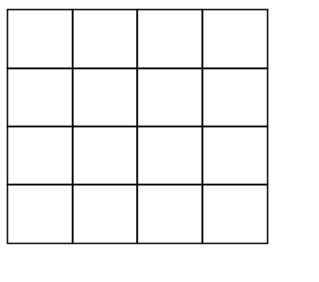
Optimized Logic Equation:

Segment b =

d. Draw the logic diagram using standard logic symbols.
Answers:
- Short Questions

- PIC provides the Interrupt vector(IV) to the CPU and the processor uses the IV as an index to the Interrupt Descriptor Table to access the ISR for the device.

- The assembly language wrapper will perform pushing and popping of the Stack register and calling the C function for the main body of the ISR. Manipulation of registers is best done using assembly language.

- Disable interrupts coming from the device:

Yes for serial and No for timer

Mask interrupts using the PIC:

Yes for serial and yes for timer

- Synchronous flip-flops only change states when clock is high.

- Outputs of the sequential logic is a function of its inputs and its previous state.

- Main memory is outside the CPU and cache memory is inside the CPU chip. Cache memory speeds up access to most recently and frequently accessed memory locations.

- 4 selector lines can select up to 16 inputs of n bits.

- B incurs gate delay.
A
B
C
…

- Evaluations

- duration of task A:
(3500-2500) *1 us=1000 us

- duration of task B:
1 tickcount*63336*1 us =65536 us

- duration between A and B start times:
1 tickcount+3400 downcounts =
65536 +3400 =68936 us

- duration between A’s start time and B’s
stop time:
68936 +65536 =134472 us

3. Programming

# The slowest interrupt rate you can program
# the PIT for is 18 hz (set upper latch=0;
# set lower latch =0.) The ISR will run 18
# times a second.
# To call display() at 9 hz, you invoke
# display() at every other ISR.

void irq0inthandc(void){
pic_end_int();/* notify PIC that its part is
done */
tickcount++;/*count the tick in global var*/
if (tickcount & 1) display();
/*call display()when tickcount is odd*/
}
- Here is a picture of the 7 segments and
the alphabetic character displays. The
display is driven by binary code ABCD
(A = 2³, B = 2², C = 2¹, and D = 2⁰)
and input values 9-14 are don’t care.
a
b
c
d
e
f
g
Segment
Identification
Letter Displays for 10 Binary Coded Alphabetic Values
(Input value 15 is for a “Lamp Test” (turns on all segments)
0 1 2 3 4 5 6 7 8 15
For segment b of the alphabetic 7 segment display shown:
a. Draw the truth table

A B C D b
0 0 0 0 1
0 0 0 1 0
0 0 1 0 0
0 0 1 1 1
0 1 0 0 0
0 1 0 1 0
0 1 1 0 0
0 1 1 1 1
1 0 0 0 1
1 0 0 1 X
1 0 1 0 X
1 0 1 1 X
1 1 0 0 X
1 1 0 1 X
1 1 1 0 X
1 1 1 1 1

b. Write the unfactored Sum of Products logic equation. (# represents not)

b =A#B#C#D# + A#B#CD + A#BCD + AB#C#D# +ABCD

c. Develop a simplified logic equation.

Here is a blank four input Karnaugh map. Label the rows and columns properly. Fill in all cells with 0, 1, or X. Circle the optimal patterns to derive a sum of products logic equation (no further factoring required) and draw the logic diagram.

Note: Horizontal and/or vertical rotations are OK as long as the gray code sequencing is maintained.
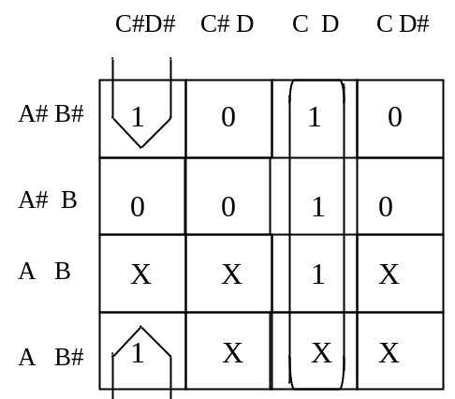

Optimized Logic Equation:

Segment b = C * D + B# * C# * D#

d. Draw the logic diagram using standard
logic symbols.

